Holding AIM Method
Based on the reciprocal of the inbound course

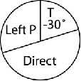
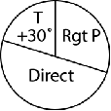
Non-STD STD
Configuration | FPM
Vref + 60 F20 idle | 2000
Gear Down | +400

If using speed brakes on descent use outboard only. When retracting bring them back smoothly and trim out the forces

VDP Formulas
GUS WEAR A HAT

VDP Timing = MAP Timing – 10% HAT(sec)

GUS WEAR A HAT
Faster A/S
Slower A/S
GS / TAS | TAS (nm/min)
360 | 6
300 | 5
240 | 4
180 | 3
120 | 2
Altitude Formulas
Alt. to Lose x3 ~ x3.5 + 10 NM to begin Descent
If going to opposite runway +10 not needed
Big Tailwind Alt to Lose x4
Time to Lose Alt. = Distance/TAS(nm/min)
VVI = Alt. to Lose ÷ Time to Lose

GUS WEAR A HAT

